Debate Synergy 1.0 Manual

Questions, comments, or ideas? Email me at alexgulakov@gmail.com for a quick response.
***Setup 1
Introduction 2
One-Click Installation 3
Initial Settings 4
Customize Styles 5
***Word 5
Speech—Window Control 6
Speech—Add to Speech 7
Standard Group 8
Virtual Tub—Tub Search, Key Docs 9
Virtual Tub—Expandos 10
Formatting—Paste Text, Remove Returns 11
Formatting—Create Cite 12
Formatting—Underline, Normal 13
Formatting—Heading, Highlight 14
Advanced—Format Fixes 15
Advanced—Debate Timer 16
Advanced—Page Header, Update TOC, Quality 17
Office Menu—Debate Synergy Options 18
Office Menu—Other Features 19
Keyboard Shortcuts 20
***Excel 20
Toolbar Features & Keyboard Shortcuts 21
Automatic Features & Options 22
***Misc 22
Q & A 23
Novice Handout 24

Introduction

***Setup

Debate Synergy is a software suite by Alex Gulakov which aims to create synergy between multiple aspects of the debate process. This initial release integrates with Microsoft Office 2007 Word and Excel. It has features for everyone—such as for research, paperless, judging, and flowing.
Debate Synergy takes advantage of the new Office 2007 interface to offer more than just macros. Fans of Word 2003 can still choose to use the original Word 2003 interface in Word 2007. It integrates easily with existing templates, is very customizable, has a single easy-to-use toolbar, a few intuitive shortcut keys, and does not require lengthy adjustments or learning. Mac users should use Bootcamp or Parallels to run Windows. There is no reason to delay installing this; get Word 2007 for Windows and don't miss out.

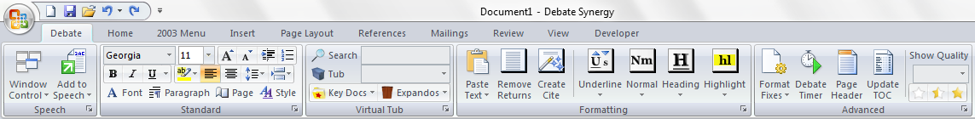
Word 2007 toolbar

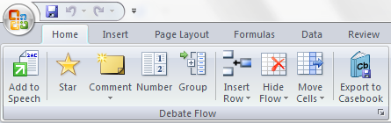
Excel 2007 toolbar

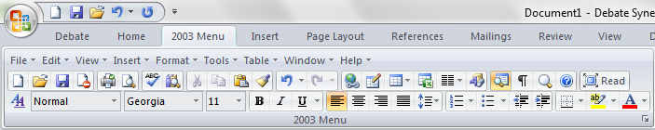
Word 2003 interface can be enabled in Options

The Debate Copy addon for Firefox is part of the Debate Synergy suite. It is not necessary for any of the Word and Excel functions, but it is greatly recommended for your debate research. Here are its features:
Enhance Google News and Lexis results with expandable full text; Save images from Google & Amazon books; Ctrl+X to easier reading of news articles; select to copy plain text; Tab to power-search Google; Tools>Copy All URLs.
Download Debate Copy here: https://addons.mozilla.org/en-US/firefox/addon/13295

One-Click Installation

Unzip Debate Synergy 1.0.zip and make sure Word and Excel are closed before installing.

Run Quick Install.bat or follow the instructions below for a manual installation.

If you have not used macros before, you need to enable them in both Excel and Word.
Press then release Alt, T, M, S or go to:
Office Menu Orb > Word Options > Trust Center > Trust Center Settings > Macro Settings
Check "Enable all macros" and "Trust access to the VBA project object model"

WORD 2007
Open an explorer window by clicking on My Computer, and type into the navigation bar:
%AppData%\Microsoft\Templates
Regardless of your Windows version, you should now be in a folder with a Normal.dotm file.

Optional: To back up your current default template, rename this Normal.dotm to Normal_backup.dotm

From Debate Synergy 1.0 folder, move Normal.dotm and the TimerSounds folder into this Templates folder.

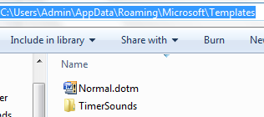
Path for a Windows 7 Admin account

EXCEL 2007
Type into the file explorer navigation bar:
%ProgramFiles%\Microsoft Office\Office12\XLSTART
Move Book.xltm into this XLSTART folder

Tip: Debate Synergy supports the use of more than one Word template (although you may need to reset the shortcut keys). Place additional templates into: %AppData%\Microsoft\Word\STARTUP

Initial Settings

Open Word. You can access DS Options under the Office Menu Orb (upper-left corner) > Debate Synergy or by clicking the small arrow expanders on the toolbar.

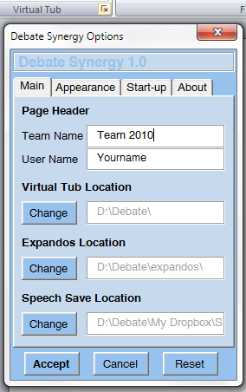
Options for Word with arrow expander highlighted (top)

Page Header
Self explanatory—input your name and the team name that you wish to appear in the page headers.

Virtual Tub
This is your “debate folder” and it should contain all your debate files. It is primarily used by the built-in search feature. Each subfolder in this folder can be searched separately, so I recommend dividing the folder into subfolders like backfiles, camp, research, work, flows, caselists, expandos, etc.

Expandos
Make this a subfolder in the virtual tub. This is used for paperless and research organization as a virtual expando system.

Speech Save
This is where all of the speeches are saved. It is used only for the paperless speech system.

Flow Save
Open Excel. Under Excel’s Office Menu Orb > Flow Options, set the Flow Save Location to where all of your flows and the casebook (judge RFDs and aff/neg reports for each round) will be saved.

Customize Styles

Unlike a usual Word template, Debate Synergy uses global styles. Even if you are working in a document created with a different template, the styles set under the DS template will be used. This eliminates the need to readjust all of your existing files. The default DS style set is the one used to write this manual, but customizing it is extremely simple.

- Click the Style button on the Standard group
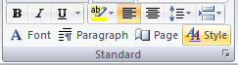
- You will see a list of styles. Select a style from the list below and click Modify
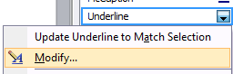
- Modify styles using the buttons and the Format dropdown menu. Make sure to check “New documents based on this template”
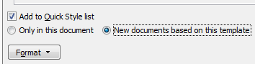

The following styles are used in DS:

Normal – this is the most important style because all other styles are based on it. For example, to change the font from Georgia to Garamond for the entire template, you only need to make one change to the Normal style.

Heading 1 – block heading. By default, this style has a page break before—this is a better way to format files in this template. However, it will create blank pages every other page in documents without this setting (this is easily fixed with the Remove blank pages Format Fix.) DS supports turning off this feature (it will insert page breaks instead) under Format > Paragraph > Line and Page Breaks > uncheck Page break before.

Underline – underlined text. For example, bold it to have all underlined text also bolded.

PageHeaderLine1 & PageHeaderLine2 – look of the page header lines. You need to adjust the Tab Stops if you modify margins. The second line has double line spacing.

Hat – section heading (like “***Setup” in this file). I do not suggest modifying this.

Additional changes:

Small text – the size of the small, non-underlined text is set in DS Options under the Appearance tab.

Page Margins – you must open the template the following way (simply double-clicking won’t work):
Office Menu Orb > Open, type in: %AppData%\Microsoft\Templates\Normal.dotm
Then click Open. The window title should say Normal.dotm – Debate Synergy.
Click the Page button on the Standard group and adjust the margins. Close the document.

***Word

Speech—Window Control

Control and navigate through the open documents.

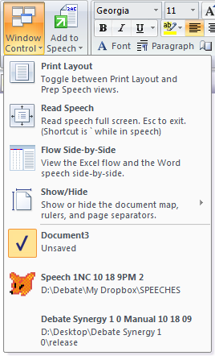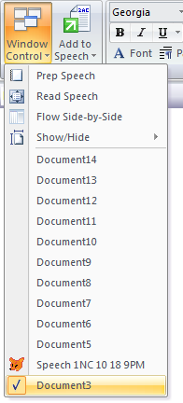
Window Control downdown adjusts to small menu size based on the number of items

Print Layout / Prep Speech – toggle between Print Layout View and Web View, which has no page separators. Prep Speech mode is better for paperless speeches and research because: a) there is no need to worry about blocks running over a page, since there are no pages, b) more content on the screen, and c) the text fits to screen (without a horizontal scrollbar) when you use Flow Side-by-Side mode.

Read Speech – uses a very full screen with 200% zoom (Ctrl+scroll to adjust zoom). The text appears as a continuous scroll and can be edited, and the document map is still visible. Press Esc to exit.

Flow Side-by-Side – puts the Excel flow on the left and the Word speech on the right side of the screen.

Show/Hide – show or hide the page separators (used in Print Layout View), document map, and rulers.

Document Navigation – all open documents appear in the dropdown list along with their locations. The current document has a checkbox and the speech document has a fox icon. You can switch between documents by clicking on them. Click on the current document to close all documents but the current one.

Keyboard Shortcuts

Ctrl+Tab – flip through Word documents, like Firefox tabs.

Speech—Add to Speech
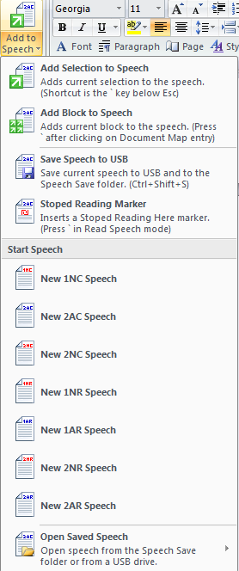
This image of the Speech dropdown is split into two

Add Selection/Block to Speech – sends the currently selected text or current block to the speech document, if opened. Thanks to Aaron Hardy for inspiring this feature.

Save Speech to USB (Ctrl+Shift+S) – saves speech to the Speech Save folder and to a USB if one is present.

Stopped Reading Marker – inserts a marker that looks like this: ₪ stopped here at 21:38 ₪

Start Speech – open a new speech document with a title that includes speech type and current date & time, like Speech 1NC 10-18 9PM.doc. This speech is saved to your Speech Save folder, allowing for an archive of all of your speeches in a debate season.

Open Saved Speech – Open a speech from the Speech Save folder or from an inserted USB.

Keyboard Shortcuts

` - located right under the Esc key, this is the multi-function key for all paperless actions.
If a speech is opened and you have text selected, it will copy that text to the speech
If a speech is opened and you have clicked on a document map entry, it will copy that block to the speech
If no speech is opened, it will prompt you to open a speech from the Speech Save folder
If you are in the speech document, it will take you to Read Speech mode
If you are in Read Speech mode, it will insert a Stopped Reading Marker

Ctrl+Shift+S – Saves speech to USB and to the Speech Save folder

Ctrl+Up/Down – Moves the current block (or section hat) before the prior block or after the next block

Ctrl+Left – Moves the current block (or section hat) to the start of the document, but after the table of contents

Ctrl+Right – Moves the current block (or section hat) to the end of the document

Standard Group

Contains the commonly-used standard Word features in a simple and organized group. This is an attempt to condense the Word 2007 interface to make it more user-friendly. Using the Word 2003 interface is another option (see “Office Menu—Debate Synergy Options”).

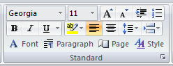
So useful

First row – font, font size, font size +1, font size -1, insert tab, number list

Second row – bold, italics, underline (dropdown for style), highlight dropdown for color, left align, center align, line spacing, and insert break dropdown

Third row – Font dialog box, Paragraph dialog box, Page Setup dialog box, and Styles sidebar

Virtual Tub—Tub Search, Key Docs

Tub Search: Search your Virtual Tub by file name.

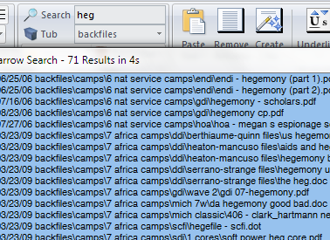

To search, type something in the search box and press enter. Select a specific Tub (these are the folders in your Virtual Tub folder) to narrow the search. The results box displays the last modified date of the file, and its location. It will search both the file path and the file title.

There are two types of search modes:
Narrow Search (matching all words) – default
Broad Search (matching any words) – used if Narrow Search returns no results or if search input contains a *

To open a file, double click on it. To open multiple files (there’s no limit), Ctrl or Shift click to select (or Ctrl+A to select all) and press Enter.

Key Docs: Bookmark key files, like bookmarks in an internet browser. These are not limited to only word documents.

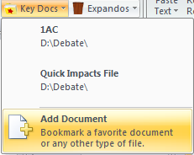

Click Add Document to add a bookmark.
Ctrl+click on a bookmark to delete it.

Virtual Tub—Expandos

The most innovative feature of DS is the Expandos system, useful for paperless debate and for research organization. You will never have to open a finished file again—the file’s document map provides the backbone for the expando pockets, and you click on a pocket to insert, into the current document, text from that file (without opening it). Expandos can be shared with the team like a regular file.

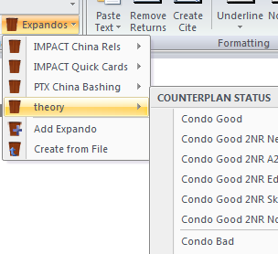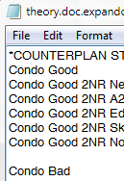
This expando manifest (right) yields this expando (left)

Click on a pocket with no text selected – inserts that pocket’s text into the current document (ie, your speech)
Click on a pocket with text selected – copies the selected text from the current document to that pocket

Add Expando or Add Pocket – creates blank expando or pocket under the assigned name. If you have text selected when clicking Add Pocket, it will copy that text to the new pocket.
(Tip: create a Random expando for uncategorized cards that you find during your research)

Ctrl+click to delete a pocket. Shift+click to open the file that contains that pocket.

Create from File – converts the current file into an expando and creates a manifest (small .txt file) which determines the look of the expando. Both the converted file and manifest are placed in the Expando folder. Important: Although the converted Word file in the Expando folder and the pre-converted file look exactly the same, they are not – the file in the Expando folder has extra information added to it.

Share the expando – send the Word file from the Expando folder and the manifest file and instruct the recipients to place them in their Expando folder. (Tip: Use Dropbox to synchronize a single Expando folder.)

Set the expando look – in the Expando folder, open and modify the expando manifest (it is named theory.doc.expando.txt when the expando is called theory.doc).
You MAY:
Change the order of the lines to change the order of the blocks
Insert a blank line to create a line separator
Insert a line that begins with a * to create a section separator with a title

You MAY NOT:
Change the name of expando pockets (you must change in the original document and then convert again)
Use any character other than letters and numbers

Formatting—Paste Text, Remove Returns

These macros are used so often that you should remember their shortcuts:
Ctrl+G to Paste Text and Ctrl+R to Remove Returns

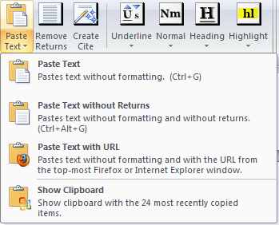
Bread & butter

Paste Text (Ctrl+G or Alt+G) – pastes text without formatting. Also removes Lexis Academic Enhanced Text if it’s present in the clipboard (this is works instantly—it takes direct access of the clipboard before it is pasted.)
In DS Options under the Start-up tab, you can set whether you want to keep selected the text you just pasted, or if you want to collapse the selection after pasting (like Word does by default.)

Paste Text without Returns (Ctrl+Alt+G) – runs both the Paste Text and Remove Returns macros.

Paste Text with URL – pastes the text, and then communicates with Firefox or Internet Explorer to get the URL of the most recently used tab and inserts that URL before the pasted text. (Tip: if you use this often, create a shortcut key in DS Options.)

Show Clipboard – shows the Office Clipboard sidebar with the 24 most recently copied items.
Remove Returns (Ctrl+R or Alt+R) – removes line breaks from selection, and then some. Also removes: soft line breaks, line wraps (- ), invisible line wraps (¬ from OCR scans), non-breaking spaces (from some PDFs), tabs, vertical tabs (from insert page break), and double spaces.

Formatting—Create Cite

By far the longest-code macro, this shortcut creates a custom-formatted cite from the selected text. The shortcut is Ctrl+T or Alt+T.

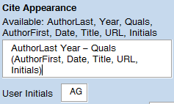
Adjust cite appearance in DS Options

You generally should put the title in quotes, and you probably also want to bold the author’s last name. It will attempt to find those variables anyways, but this will greatly help. Running it is risk free—it will leave behind any unused text. For example, it will output the following cite if run when the text below that cite is selected.

Ferguson 4 – Senior Fellow at Stanford University’s Hoover Institution (Niall, July August, “A World Without Power”, http://www.foreignpolicy.com/story/cms.php?story_id=2579, AG)

http://www.foreignpolicy.com/story/cms.php?story_id=2579
“A World Without Power”
By Niall Ferguson
Senior Fellow at Stanford University’s Hoover Institution
July/August 2004

It works especially well for Lexis. For example it will take this selection

December, 1995

94 Mich. L. Rev. 752

LENGTH: 36605 words

SYMPOSIUM: Reflections on United States v. Lopez: "A GOVERNMENT OF LIMITED AND ENUMERATED POWERS": IN DEFENSE OF UNITED STATES v. LOPEZ

NAME: Steven G. Calabresi *

BIO:
* Associate Professor, Northwestern University School of Law.

And output

Calabresi 95 – Associate Professor, Northwestern University School of Law (Steven G., December, “SYMPOSIUM: Reflections on United States v. Lopez: "A GOVERNMENT OF LIMITED AND ENUMERATED POWERS": IN DEFENSE OF UNITED STATES v. LOPEZ”, 94 Mich. L. Rev. 752, Lexis Law, AG)

Formatting—Underline, Normal

F1 toggles text between underlined and small size, and F2 resets the selection to normal text.

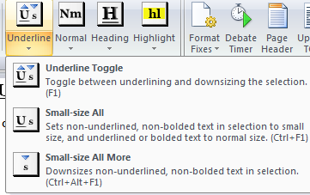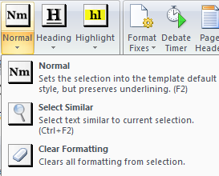
The second-tier functions (Small-size All and Select Similar) are highly useful as well

Underline
Underline Toggle (F1) – pressing it on non-underlined text sets the text to the Underline style; pressing it on underlined text removes the underlining and sets the text to the small size (configured in DS Options.)

Small-size All (Ctrl+F1) – select a partially-underlined card that and this will set the non-underlined and non-bolded parts to the small size, and the underlined or bolded text to the Normal size. You can select an entire document and run this macro.

Small-size All More (Ctrl+Alt+F1) – decrease font size of all non-underlined and non-bolded text in selection

Normal
Normal (F2) – sets the selection to the normal style and removes highlighting, essentially creating plain text. Does NOT remove underlining if that underlining was set using a unique Underline style (such as in the DS template and many other templates). Same for bolded text.

Select Similar (Ctrl+F2) – selects text of a format similar to the currently selected text. Useful for reformating all headers or all underlined text in a document.

Clear formatting – absolutely clears all formatting, resetting the text to Normal style. If run from the menu, it does not preserve anything. Use Ctrl+Space to “clear text” – it will run a similar function that clears all formatting, but preserving Heading styles.

Formatting—Heading, Highlight

F3 structures the document with block headings, and F4 highlights text.

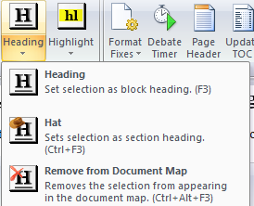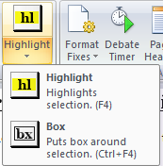

Heading
Heading (F3) – set selection or current paragraph as block heading. Running the macro will insert a page break beforehand if you turned off “page break before” as a default for the Heading style (see Customize Styles).

Hat (Ctrl+F3) – sets text as a “section heading.” It inserts three *s before the text and puts the text in the non-printing bottom gutter of the prior page. In the document map, it creates a blank line before the section hat entry. The section hat is bolded and underlined in the table of contents.

Remove from Document Map (Ctrl+Alt+F3) – often Word will automatically make some text appear in the document map. To fix the document map, select the entire document and run this macro; click “no” for removing styles from the document map.
Second, some templates use a Heading 2 style for tags. Use Select Similar to select all of these tags and run this macro; click “yes” for removing styles.
To entirely clear the document map, select the entire document and run this, clicking “yes” for removing styles.

Highlight
Highlight (F4) – toggle between highlighting and un-highlighting the selection or current word. Set color in the color picker on the Standard group.

Box (Ctrl+F4) – toggle between boxing and un- boxing the selection or current word.

Advanced—Format Fixes

Many useful formatting fixes.

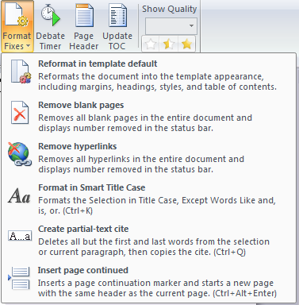
The descriptions in the image are the same as the ones below

Reformat in template default – Reformats the document into the template appearance, including margins, headings, styles, and table of contents.

Remove blank pages – Removes all blank pages in the entire document and displays number removed in the status bar.

Remove hyperlinks – Removes all hyperlinks in the entire document and displays number removed in the status bar.

Format in Smart Title Case (Ctrl-K) – Formats the Selection in Title Case, Except Words Like and, is, or.

Create partial-text cite (Ctrl+Q) – Deletes all but the first and last words from the selection or current paragraph, then copies the cite.

Insert page continued (Ctrl+Alt+Enter) – Inserts a page continuation marker and starts a new page with the same header as the current page.

Keyboard Shortcuts
Turn on Caps Lock and open as many documents as you want. All those documents will then be converted into your DS template style. However, running this “Reformat in template default” macro will take some time.

Advanced—Debate Timer

Press F10 to bring up a Debate Timer with an incredible amount of features.

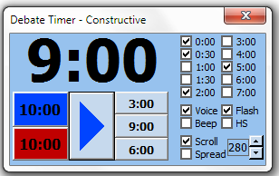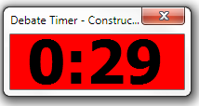
Automatically resizes into compact mode. Flash alert (right).

Always on top – the timer always stays on top of every window, even if you use another application

Compact – uses the mini-window mode when running, unless you hover the mouse over it

Adjust time – simply click on the timer digits to set a different time or adjust prep

Prep time – keeps aff (blue) and neg (red) prep time

Stopwatch – adjust the time to zero and click start to have it count up

HS/College times – check “HS” to use the 8-5-3 format instead or the 9-6-3 format

Alerts – at any moment you can check/uncheck the intervals you wish to be alerted at, using these alerts:

Voice – speaks the time. If you install the TimerSounds folder, the voice is a remix of the Apollo 11 launch sequence (available here: http://history.nasa.gov/ap11fj/01launch.htm) and says “liftoff” at the end. If you did not install this folder, it uses the build-in Microsoft system voice.

Flash – changes the window to red for 2 seconds

Beep – beeps at the specified interval

Scrolling – there are three ways to scroll your speech:

Page Down – tap it to scroll down (at a smoother pace than the default Word function), or use mouse wheel

Scroll – automatically scrolls the document at the specified speed. This is a “light” function since it doesn’t override your existing ability to scroll with the mouse or Page Down

Spread (Scroll must be enabled first) – brings up a window which displays a few words at once as it follows along in the document. It will only pick up underlined or bolded words. You can adjust the position by setting your cursor to a different location. In the window, you can adjust font size, words at once, speed, and pause Spread mode. Close this window to have it just follow along in the document using a different font color. I recommend this for speaking practice, not speeches, since it is hard to mark cards.

Advanced—Page Header, Update TOC, Quality

Page Header and Update TOC offer more features than usual, and Show Quality allows for quality control.

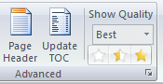

Page Header (F11) – inserts a page header using the names you configured in DS Option on the left side, and the document title (if it has been saved) and page count on the right side. It will also recognize and support documents with multiple sections. Example:
DocTitle Team 2010
1/20 Yourname

Update TOC (F12) – inserts a first page which contains the table of contents. If there is already a table of contents, it will update it. It will use the document name or “Table of Contents” for the heading of that first page. Section hats will be emphasized. Repeating consecutive entries will be removed if that setting has been turned on in DS Options under the Appearance tab. This also removes the first entry (ie, the “Table of Contents” entry that is the heading for that first page.)

Show Quality (Alt then X then 1, 2 or 3) – “quality control” your file. Select a card and click on the stars to give it a rating. Then, you can select from the drop down to have it show only the best, medium, or worst of the cards. It is unobtrusive (doesn’t modify the text in any way) so someone without the template won’t even notice it.
It is my hope that debate camps use this in preparing their files as well as in the final product. It is also useful for creating short versions of blocks that you can switch to easily during the speech. You can also use it to preserve full text for all cards (set unused text to worst).

Office Menu—Debate Synergy Options

Configure user options for Debate Synergy.

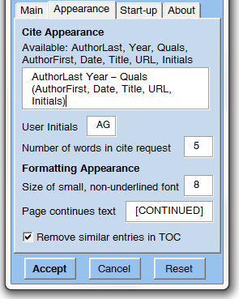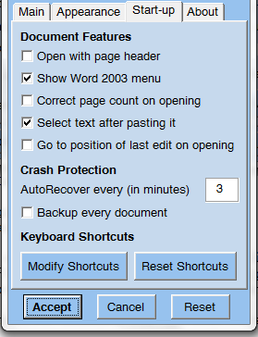
For the Main tab, see the “Initial Settings” page

Appearance
Cite Appearance – see “Formatting—Create Cite”

Number of words in cite requests – the number of first and last words created when by the “Create partial-text cite” Format Fix. Words actually means words, ignoring punctuation and other non-words. I don’t recommend going above 10 since long search strings are sometimes harder to find on Google and Lexis.

Size of small, non-underlined font – the small font size used by Underline Toggle and Small-size All.

Page continues text – the notation used by the “Insert page continued” Format Fix.

Remove similar entries in TOC – removes similar repeating and consecutive table of contents entries

Start-up
Open with page header – opens new documents already with the page header
Show Word 2003 menu – shows fully-featured Word 2003-style menu (see “Introduction” for screenshot)
Correct page count – ensures the page count is correct when opening documents, but delays file opening time
Select text after pasting it – keeps the pasted text selected after running the Paste Text macro
Go to position of last edit on opening – resumes from last edit position, but delays the closing of files

AutoRecover every – set the minute intervals at which to save the document’s AutoRecovery information
Backup every document – backup copy of every document in the same folder (for those who are very worried)

Keyboard shortcuts – modify the shortcuts for each macro or reset them to the template defaults

Office Menu—Other Features

The Debate Synergy tab in the Office Menu includes some extra features.

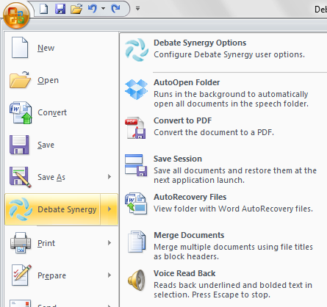

AutoOpen Folder – specifically designed for those who use a viewing laptop for paperless. Run this on the viewing laptop before the round and set the speech folder on the viewing laptop to be a DropBox folder (If you don’t know what DropBox is, it is a folder synching program—find out more at http://getdropbox.com/). Then, any document you save (remember to also close the file) to this DropBox folder from your personal laptop will be transferred by DropBox to the viewing laptop and then automatically opened by this feature on the viewing laptop. In short, this eliminates the need for USB use.

Convert to PDF – one-click PDF conversion. Saves the PDF to the same location as the current document.

Save Session – saves all of your documents and remembers which documents were opened. The next time you open Word, it will prompt to restore these documents. Similar to Firefox’s Session Restore.

AutoRecovery Files – opens the folder containing Word’s AutoRecovery files (ie, crashed documents).

Merge Documents – merge multiple documents. Gives you the option to use file names as block headers.

Voice Read Back – reads all the underlined and bolded text in selection using the Microsoft system voice. Press Escape to stop. For example, set it to read an overview block, and you can continue working as it is reading.

Save (Ctrl+S)– the built-in Save feature will add the date and your name to the suggested filename, ie:
Aff Updates 10-18 Gulakov.doc

Keyboard Shortcuts

Notice the keyboard shortcut grouping: G, R, and T are close and F1-F4 are consecutive like on the toolbar.

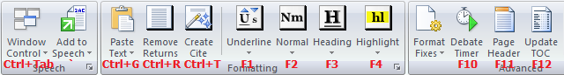

Formatting
Shortcut | Macro | Description
Ctrl+G | Paste Text | pastes text without formatting
Ctrl+Alt+G | Paste Text w/o Returns | pastes text without formatting and removes returns
Ctrl+R | Remove Returns | removes returns
Ctrl+T | Create Cite | creates cite from selection
F1 | Underline Toggle | toggle between underlining and small-sizing
Ctrl+F1 | Small-size All | small-size non-underlined, normal-size underlined
Ctrl+Alt+F1 | Small-size All More | downsize non-underlined by one font size
F2 | Normal | normal style, preserves underlining
Ctrl+F2 | Select Similar | select similar text
F3 | Heading | sets selection as block heading
Ctrl+F3 | Hat | sets selection as section hat
Ctrl+Alt+F3 | Remove from Doc Map | removes selection from document map
F4 | Highlight | toggle highlighting selection
Ctrl+F4 | Box | toggle box around selection

Advanced
Ctrl-K | Smart Title Case | Formats the Selection in Title Case, Except Small Words
Ctrl+Q | Create partial-text cite | deletes all but the first and last words and copies cite
Ctrl+Alt+Enter | Insert page continued | inserts a page continues marker and starts page with same header
F10 | Debate Timer | multi-featured debate timer
F11 | Page Header | insert customized page header
F12 | Update TOC | insert first page containing TOC or update TOC

Speech
` (under Esc) | Speech | context-dependant key for all paperless actions
Ctrl+Shift+S | Save Speech to USB | saves document to speech folder and to inserted USB
Page Down | Scroll Down | smooth scroll down
Ctrl+Tab | Window Cycle | flip through open Word documents
Ctrl+Up | Block Up | moves block before the prior block
Ctrl+Down | Block Down | moves block after the next block
Ctrl+Left | Block Start | moves block to the start of the document
Ctrl+Right | Block End | moves block to the end of the document

Toolbar Features & Keyboard Shortcuts

***Excel

The DS group on the Excel toolbar has many features for flowing.

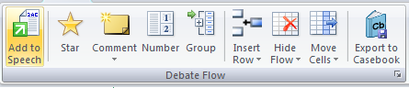

Important: none of the Excel macros can be run when you are editing a cell (cursor is blinking). Press Esc (or Tab or Enter) to stop editing the cell.

Paperless
Add to Speech (`) – copies the selected cells from Excel to the speech in Word, sets Flow Side-by-Side, and gives the text a corresponding red or blue background color

Markup
Star (F1) – toggle highlighting and bolding the cell

Comment (F2) – inserts a comment next to the cell. Useful for cross-x questions or judging comments

Display comments – hide/show all comments

Number (Ctrl+Enter) – insert the next number when in 2AC/oncase 1NC column, or skip to the next number if in a different column

Group (Ctrl+G) – group/ungroup the cells in the left column (so select the cells in the “answer” column)

Flow Appearance
Insert Row (Ins) – inserts row at current location
Insert Overview (Ctrl+Ins) – inserts three rows at the top of the current column
Delete Row (Ctrl+Del) – delete current row (prompt if it contains text)

Hide Flow (Ctrl+Backspace) – hides the flow, can be unhidden by right-clicking on the bottom tab bar and selecting “Unhide”
Add Flow (Ctrl+Plus) – add a blank flow similar (in name and type) to the current one

Copy Right (Ctrl+Right) – extends selection by coping it over two columns (prompt if it contains text) and italicizing the text
Move Up/Down/Left (Ctrl+Up/Down/Left) – moves the cell in the specified direction (prompt if it contains text)

Casebook
Export to Casebook (F12) – after the round, you can export the aff, neg, and judge info from the casebook page into a centralized casebook located in the Flow Save folder. It will not export that given data if you leave Aff, Neg, or Judge names blank. For the teams, it exports the tourney name and date, plan & advantages or 2nr/1nc lists. For the judge, it exports the tourney name and date, decision and team names, and comments.

Automatic Features & Options

Many of the flowing features are automatic and don’t require key shortcuts or the toolbar. You can enable these automatic features in the Excel Orb Menu > Flow Options

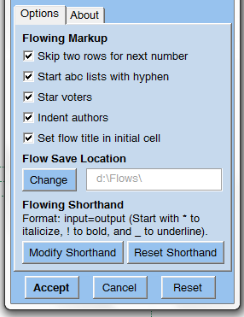

Flowing shorthand – automatically changes debate shorthand into full words, ie “vi” to “voting issue”
Click Modify shorthand to change or add values. Delete all values to disable the feature. If there is an argument you make often, write it out and create a shortcut word for it. You can also start an entry with * ! or _ to add markup to the result. For example, add this value to get uniqueness overwhelms the link when typing uowl:
*uowl=uniqueness overwhelms the link

Ctrl+Page Up/Page Down – navigate between flows, with the flow title displayed in the center of the screen

AutoSave – enter the name of the tourney to save by that name and today’s date to the Flow Save folder. You can save with or without macros—this determines whether macros are available next time you open this flow

AutoList – the advantage and 1NC lists in the casebook sheet are automatically generated as you title the flows

Markup
Skip two rows for next number – just press enter twice in the 2AC/oncase 1NC column for the next number

Start abc lists with hyphen – start an entry with - to convert that the entry into a list. The next cells will also be numbered until you leave a cell blank. (start the entry with '- if Excel doesn’t permit the former)

Star voters – voting issues and conditionality are automatically stared

Indent authors – cells ending with numbers are slightly indented

Set flow title in initial cell – what you type in the default-selected cell (A4) on a flow becomes the flow title

Q & A

***Misc

Q: How long did this project take and what inspired it?
During the early hours of July 29, 2009, I started thinking about the ideal debate technology, and a lot of great ideas struck me. I decided to write them down in an essay, and in the morning when I was done I sent the essay to Scott Phillips for his opinion. He liked it and posted on a blog he co-runs:

http://www.the3nr.com/2009/07/29/guest-post-alex-gulakov/

I didn’t have any formal training, so spent a few weeks learning to program Word 2007 by googling for example code. I had programmed the timer a few weeks earlier, but with that essay it really came together as a holistic project for all aspects of debate, which is why I called it Debate Synergy. Overall it took about three months to complete.

I am pleased to have implemented most of my ideas. Some, such as the bubble-like flowing, turned out to be impractical and were scrapped. Many other ideas were also scrapped in favor of simplicity and making it the least confusing user experience possible, so even novices can use it. I aimed to design it with the least keyboard memorization and adjustment necessary.

Q: I am a debate coach, and I am wondering if I should switch my team to paperless.
I would say that DS makes it extremely simple to use paperless, particularly with the toolbar interface. Paperless may sound great, but it takes time to adjust. I would caution against pushing it on a team that’s not ready (unless cost constrains force it.)
Should you buy a viewing laptop? Maybe, but it seems to me that the teams that don’t have their own laptops probably don’t like using computers for debate, so having a printer to print your speech makes more sense.
The main advantages to paperless are massive organization improvements and cost savings, while the disadvantages are unfamiliarity and the fact that the other team can easily take all the evidence in your speech.

Q: What can be done to restrict the other team from taking evidence by saving your speech?
I wrote a way to securely save the speech. It disables cutting and copying and only allows the speech to be viewed and opened for three hours after it is created. However, I have reservations about releasing it for the debate community because some might view it as unwelcome security or a way of saying “you can’t be trusted.” If you are interested, start a discussion on a popular debate website, and I am open to releasing this feature if there is a consensus for its necessity.
Other solutions include printing the speech or adopting a norm of full-text disclosure so that this isn’t an issue.

Q: What are the plans for the future?
I am eager to hear anyone’s ideas for new improvements and features for Debate Synergy—email me.
I will likely release a new version in a year, when Microsoft Office 2010 comes out (hopefully with native Mac OS X support).
I am working more on the Debate Copy addon for Firefox, because there are more features possible using the web platform.

Q: Can I view, modify, or use elsewhere the code behind Debate Synergy?
Debate Synergy is open source as per the terms of the GPL 3.0 license. The main points are that you must credit me in the derivative works and keep it open source. You may view and modify the source code for your own use. Please email me at alexgulakov@gmail.com if you have questions regarding how something was coded.

Novice Handout

This is a shortened version of this manual designed to be given to a novice debater after Debate Synergy has been installed on his or her computer and the user name and team name have been set in the options.

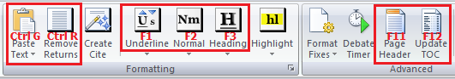
You will need to know how to use the features in the red boxes

Paste Text (Ctrl+G) – when you find a relevant article online, you should copy the text of that article. However, if you paste it into Word using Ctrl+V, you will often paste pictures and other styles that mess up the look of the document. It is important that you use this button or the shortcut key Ctrl+G to paste just the text without any formatting.

Underline (F1) – if you find something you wish to underline when reading through the pasted text, select that text and press F1. If you underlined something by mistake or wish to remove underlining, select the underlined text and press F1 again.

Normal (F2) – in case the text ever looks odd or has weird formatting, remember that you can always “reset” it to plain text by pressing F2.

Remove Returns (Ctrl+R) – next, you will want to make the text of the card look like a single block, so select the paragraphs you’re using for the card and click this button or press Ctrl+R. I am assuming you know how to create a citation and a tag for this block of text.

Heading (F3) – group the cards on a similar subject or point of view onto one or more pages, and write on the first line of that page a heading for the page, such as “Economy High Now,” then select what you just wrote and press F3 or hit the Heading button.

Page Header & Update TOC (F11 and F12) – after you are done with your entire file, simply hit these two buttons for a page header (on top of every page) and a table of contents on the first page. Double click the page header to edit it and type in the name of the file on the first line.

Save (Ctrl+S) – click the save button in the upper-left corner Office Menu or press Ctrl+S. You will notice that your name and today’s date are already at the end of the file name. Change the first part of the file title as appropriate and click save.

